Fusu

There are three major university ranking systems used widely — US News & World Report, Quacquarelli Symonds(QS), and Forbes. US NEWS & World Report is an American media company that publishes news, consumer advice, ranking, and analys. It was launched in 1948 as the merger of domestic-focused weekly newspaper U.S news and international-focused weekly magazine World Report. Quacquarelli Symonds is a UK company specialising in the analysis of higher education institutions around the world. It is the world’s largest international higher education network, connecting universities, business schools and students. Forbes is an American business magazine owned by Integrated Whale Media Investments and the Forbes family. It features articles on finance, industry, investing, and marketing topics. They all have different methodologies and factors they weigh to build the ranking. Their ranking factors and the corresponding weights remain unchanged for most of the parts but have been modified every year.

Taking example of the year 2021, the ranking factors of each organization were listed as below.

| US News | QS | Forbes |
| --- | --- | --- |
| * Graduation and retention rates - 22% * Social mobility - 5% * Graduation rate performance - 8% * Faculty resources - 20% * Undergraduate academic reputation - 20% * Student selectivity for the fall 2020 entering class - 7% * Financial resources per student - 10% * Average Alumni giving rate - 3% * Graduate indebtedness - 5% | * Academic Reputation - 40% * Employer Reputation - 10% * Faculty/Student Ratio - 20% * Citations per faculty - 20% * International Faculty Ratio - 5% * International Student Ratio - 5% | * Alumni salary - 20% * Debt- 15% * Return on investment - 15% * Graduation rate - 15% * Forbes American Leaders list - 15% * Retention rate - 10% * Academic success - 10% |

There are some factors they all considered in common. For example, US News and Forbes all take graduation and retention rates into account. It is interesting to notice that when US News calculated their graduation rate performance, they compared each college's actual six-year graduation rate with what they predicted for its fall 2014 entering class. The predicted rates were modeled from factors including admissions data, the proportion of undergraduates who were awarded Pell Grants, school financial resources, and etc. Then they divided each school's actual graduation rate by its predicted rate and took a two-year average of the quotients for use in the rankings. Forbes, as a business magazine, ranked colleges and universities in the U.S. based on the return on investment and outcomes they delivered for their students. Schools placed well if their students graduated on time, secured high salaries and low debt, and went on to have successful careers. The QS World University Rankings, on the other side, compiled using 6 simple metrics to capture university performance.The highest weighting of any metric is allotted to an institution’s Academic Reputation score. Based on the Academic Survey, it collates the expert opinions of over 130,000 individuals in the higher education space regarding teaching and research quality at the world’s universities.

<https://www.usnews.com/best-colleges>

<https://www.qschina.cn/en/university-rankings/usa-rankings/2021>

<https://www.forbes.com/top-colleges/>

Caro

Tina

During the application season, we submit personal information such as our name, email address, and other contact information to a variety of examination websites and online application systems. However, we've recently seen a trend: email addresses other than the registration site are receiving application-related emails from various institutions, such as invitations to events, virtual information sessions, newsletters, and so on. Although we are excited to learn about different schools and programs and to participate in after-school activities, the problem is that these emails are sent to other email accounts that we use frequently in our personal lives rather than the email account where we enrolled for the application. I believe this is to track our personal information via an online tracker and to send school emails to our personal email accounts, which we use more frequently to promote and advertise the school.

There are several potential unethical uses of data in school ranking algorithms, such as improving student resources, boosting prospective financial resources, and improving academic performance by buying students' grades. Like ETS and Common Application. From either the test center's or the school's perspective, the leaking and purchasing of student information should not occur, however it can be justified under the influence of consequentialism. This is due to the fact that it is done for profit. On the contrary, this is utterly unethical action from a deontological standpoint. It infringes on students' privacy and causes a leak of personal information, and all data is used without their knowledge or permission.

The second ethical concern is Academic Reputation, which we observe is measured differently by the three ranking sites. For example, QS' Academic Reputation, which is weighted at 40%, is a score calculated by collecting a large number of expert opinions. US News, on the other hand, has a relatively small weighting of 20%, and I think it has less credibility, as it is a Peer Assessment Survey. There is a large lot of artificial manipulability regardless of whether of the following criteria is utilized. Money transactions are done as well.

Tommy

In addition, we noticed that the college ranking systems create inequality and unfair treatment in selecting different groups of students. Some students have been discriminated against by others in college admissions, especially by those in power and wealth. According to the Equality of Opportunity Project, many top universities, including Princeton and Yale, admit more students from the top 1 percent of earners than the bottom 60 percent combined, which means the systems create incentives for universities to favor wealthier students over less wealthy applicants.

The unfair treatment comes from individuals and from the way our college ranking systems are created. As we mentioned before, the common factors in the ranking systems are students’ performance, background information, lower acceptance rate, alumni giving. It is not hard to imagine that students’ performance on standardized admissions tests is highly correlated with family background, also wealthier students are more likely to find an internship related to his/her major. Colleges are willing to focus on their elite students and faculty to gain a higher ranking in the system. Here is another feedback loop, college ranking cannot directly measure the college quality, but it is correlated with colleges’ academic outcomes. The more the college emphasis on students’ background and financial resources, the more potential alumni give in the future and result in a higher ranking in the system. For example, Southern Methodist University conducted a billion-dollar fundraising drive devoted to improving faculty reputation and recruiting students with higher SAT scores, which has gained a higher ranking in the system. Meanwhile, Georgia State University has dropped 30 spots because of the emphasis on cultivating moderate-income students (Wermund).

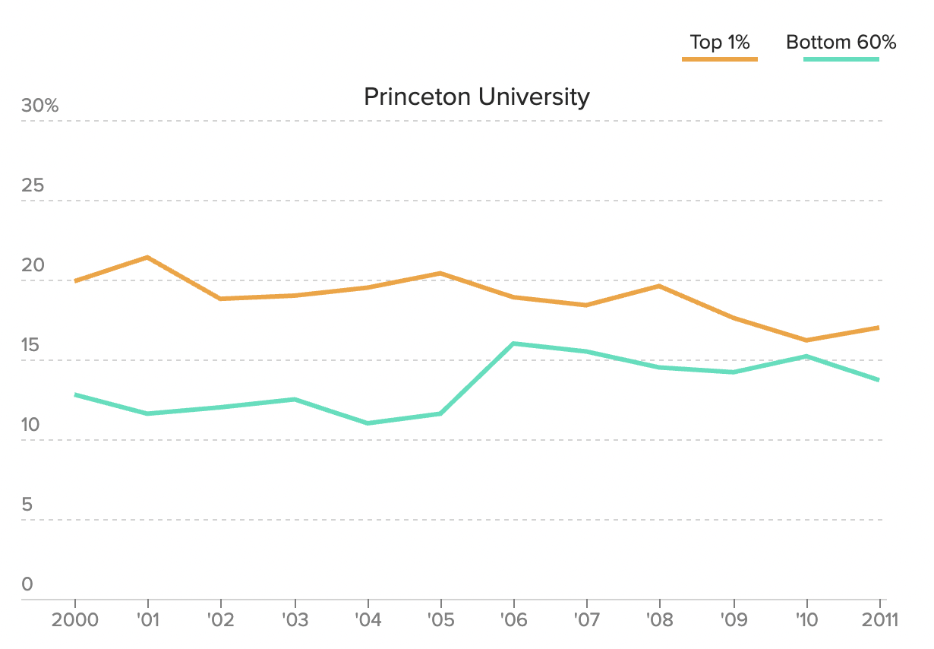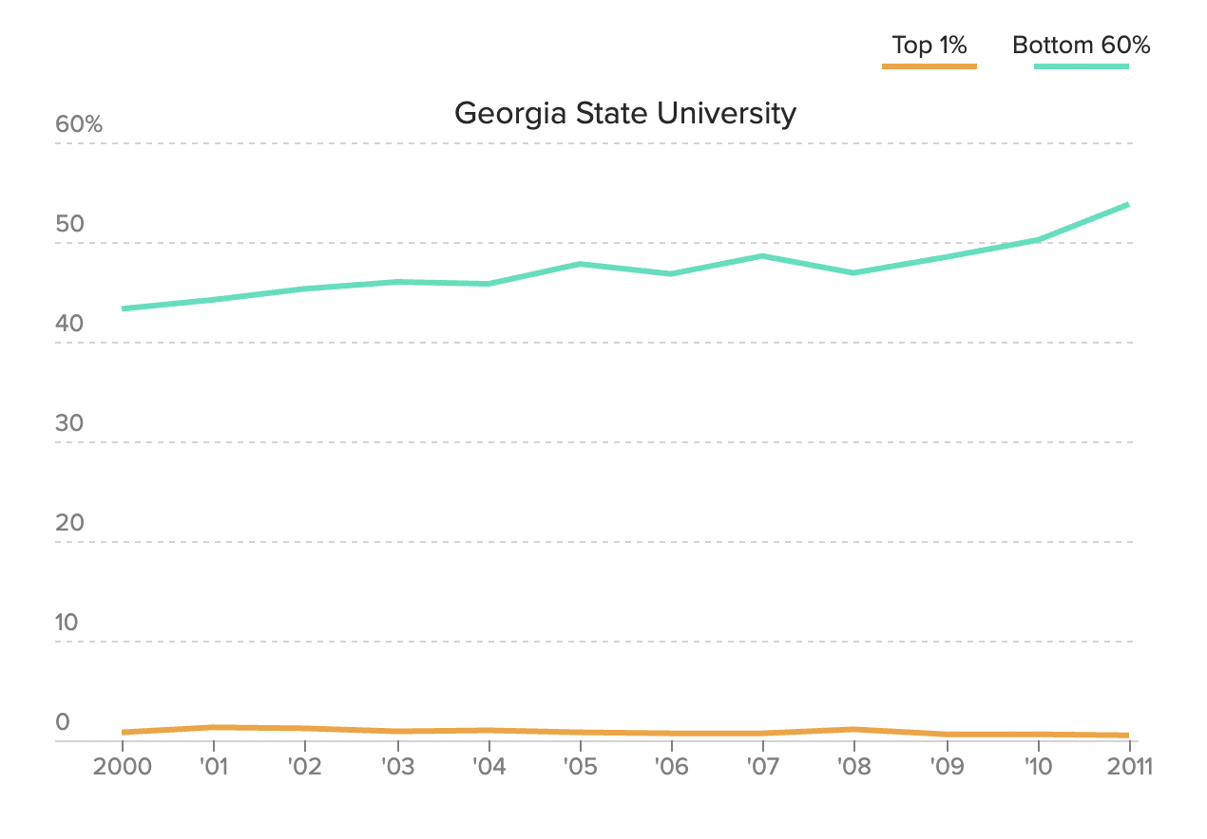

Furthermore, universities are looking at family backgrounds when you submit the admission application. You are asked to fulfill the survey in which indicates whether you have siblings or family members who are currently in the university or have already graduated. Some elite universities have a long history of catering to children of alumni to keep the denotation flowing. The research indicates that more than 40% of students in Harvard who have siblings or other family members attended before (Wermund). All these criteria are unofficial guidelines for universities’ admission decisions, as well as in the ranking system. The system is not fair to students with lower-income and normal backgrounds. As F. King Alexander, president of Louisiana State University said, “I think U.S. News has done more damage to the higher education marketplace than any single enterprise that’s out there” (Wermund).

Citation

Wermund, Benjamin. “How U.S. News College Rankings Promote Economic Inequality on Campus.” *POLITICO*, https://www.politico.com/interactives/2017/top-college-rankings-list-2017-us-news-investigation/.

Allen - According to Quacquarelli Symonds(QS) World university ranking system, the Academic Peer Review weighs 40%. This may create inequality and unfair treatment. As a university, it is possible for it to fake the real data by bribing peers. Because once other peers receive the benefit from it, they will give it a good assessment. For example, Hong Kong University of Science and Technology ranks 27 in QS world ranking. But it ranks 47, 122, 250 in THE, USNews, ARWU. What’s more, the ranking variance is 100.9835. As a result, the possibility of inequality is increased.

On the other side, universities may give false or fake information to those ranking systems. The company that makes the annual Best Colleges rankings said that the University of Oklahoma gave “inflated” data on its alumni giving rates for two decades.For the 2019 Best Colleges rankings, the university originally said its two-year alumni giving rate was 14% but later informed U.S. News that the correct number is 9.7%. The false data affected Oklahoma’s placement in the national universities, best value schools, top public schools, best colleges for veterans and A-plus schools for B students rankings and lists.

Michael

To sum up, as the university rankings play a large part in students' choice of schools, with a possible thirst to gain a higher ranking, universities might have created feedback loops that negatively affect certain students and put them in a disadvantaged situation by favoring wealthier students. Besides unfairness, misinformation and fake data is another outcome resulted from university’s addiction to higher ranking. Also, in order to raise their selectivity, universities tend to reach out to more students by buying students’ information from various education-related websites which is in fact an invasion of student privacy.

With more understanding of the college ranking system, one should be aware of the instance of cognition bias which suggests that our impressions of universities are so confined by all the news and rankings around us that we might not actually know what these schools have a good reputation for and we fail to make an unbiased decision on choosing the right university for ourselves. The limitation of our research remains that we only know the surface of their methodology, but we don't know how they actually perform the procedure. Looking forward, we hope that whoever is reading this report and about to enter a university, you will pay less attention to the rankings.